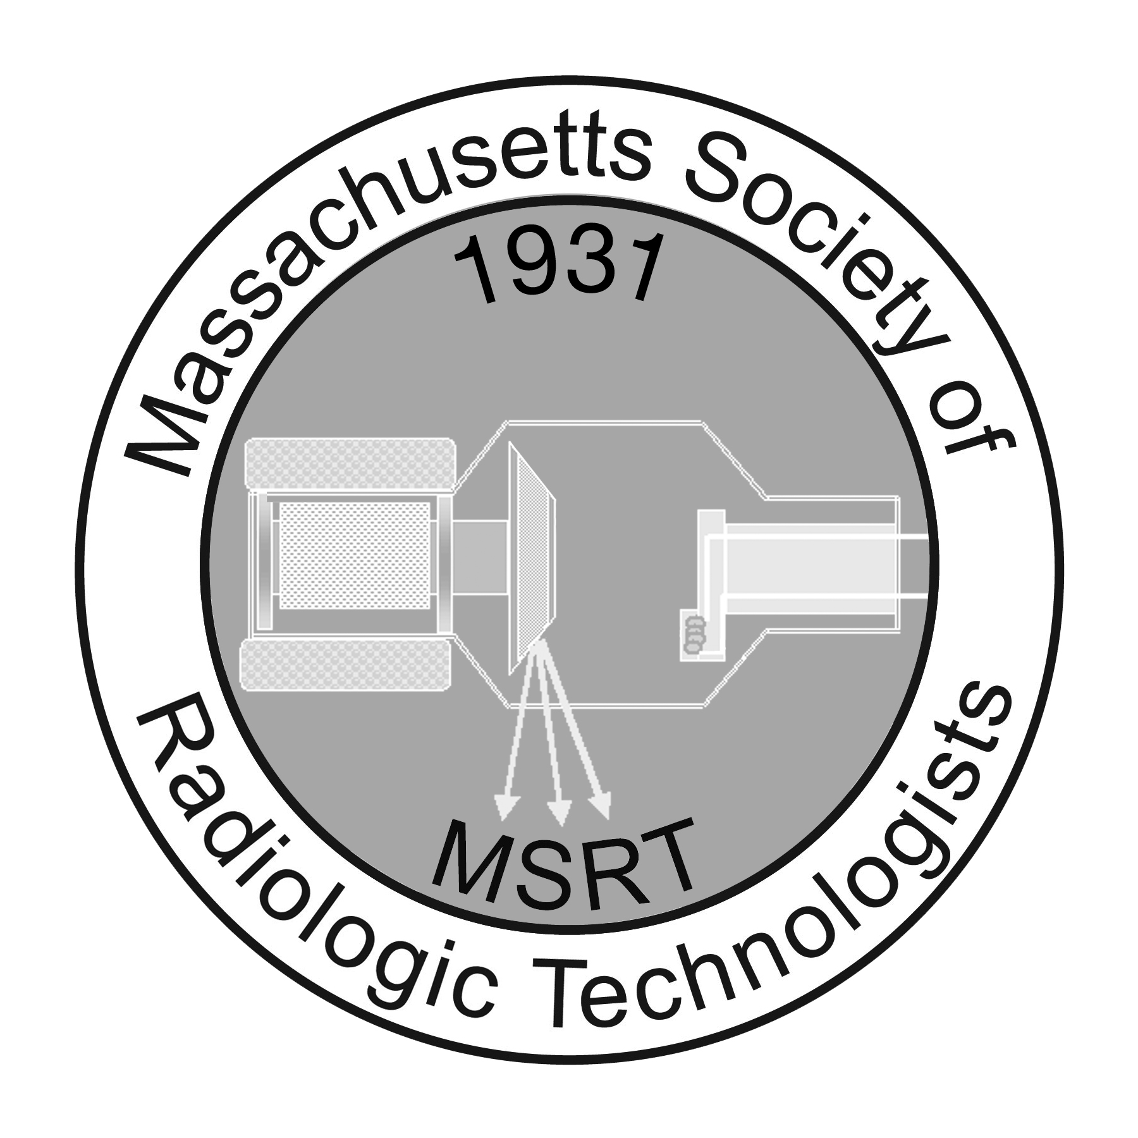
2013-2014 Conference Committee Annual Report
Submitted By Kerri Prugnarola, RT (R) (M) &
Eric McAdam, BA RT(R) (T) Conference Co-Chairs

The 2014 annual MSRT conference was another success. The conference was held at the Westford Regency Hotel again, due to convenient location for most attendees, and was held on Tuesday-Thursday. Our theme of "Reaching New Heights" went over very well with many lectures pertaining to where the radiology profession has come from, and where it may lead to in the future.
This year we had 10 teams competing in Buzz Bowl. The competition was very fierce, however Bunker Hill Community College dominated and they were crowned as champions. Quinsigamond Community College fought very hard as well and were named the runners up. Third place was taken by Middlesex Community College. Thank you again to the Buzz Bowl committee for their hard work before, during, and after the competition.

As was done the past couple of years, we once again offered several mammography credits Tuesday night.

On Wednesday night, DJ Brad entertained the crowd and allowed everyone to let loose on the dance floor. This year’s theme at the dance was to dress in your favorite sports gear. Molly Krugh from Northern Essex Community College won a pair of Red Sox tickets because of her awesome team spirit.

We would also like to once again thank all of the vendors and sponsors associated with the 2014 MSRT conference. It was great to have you all there. Next year’s conference committee is already working on the 2015 annual conference.

A big thank you to all of our MSRT members and board members for a successful conference. We hope to see you all again next year!

