Massachusetts Society of Radiologic Technologists
&
Quarter Century Club

Entry Level Scholarship Awards
Providing financial assistance to eligible members enrolled in an
Accredited Radiologic Technology Program

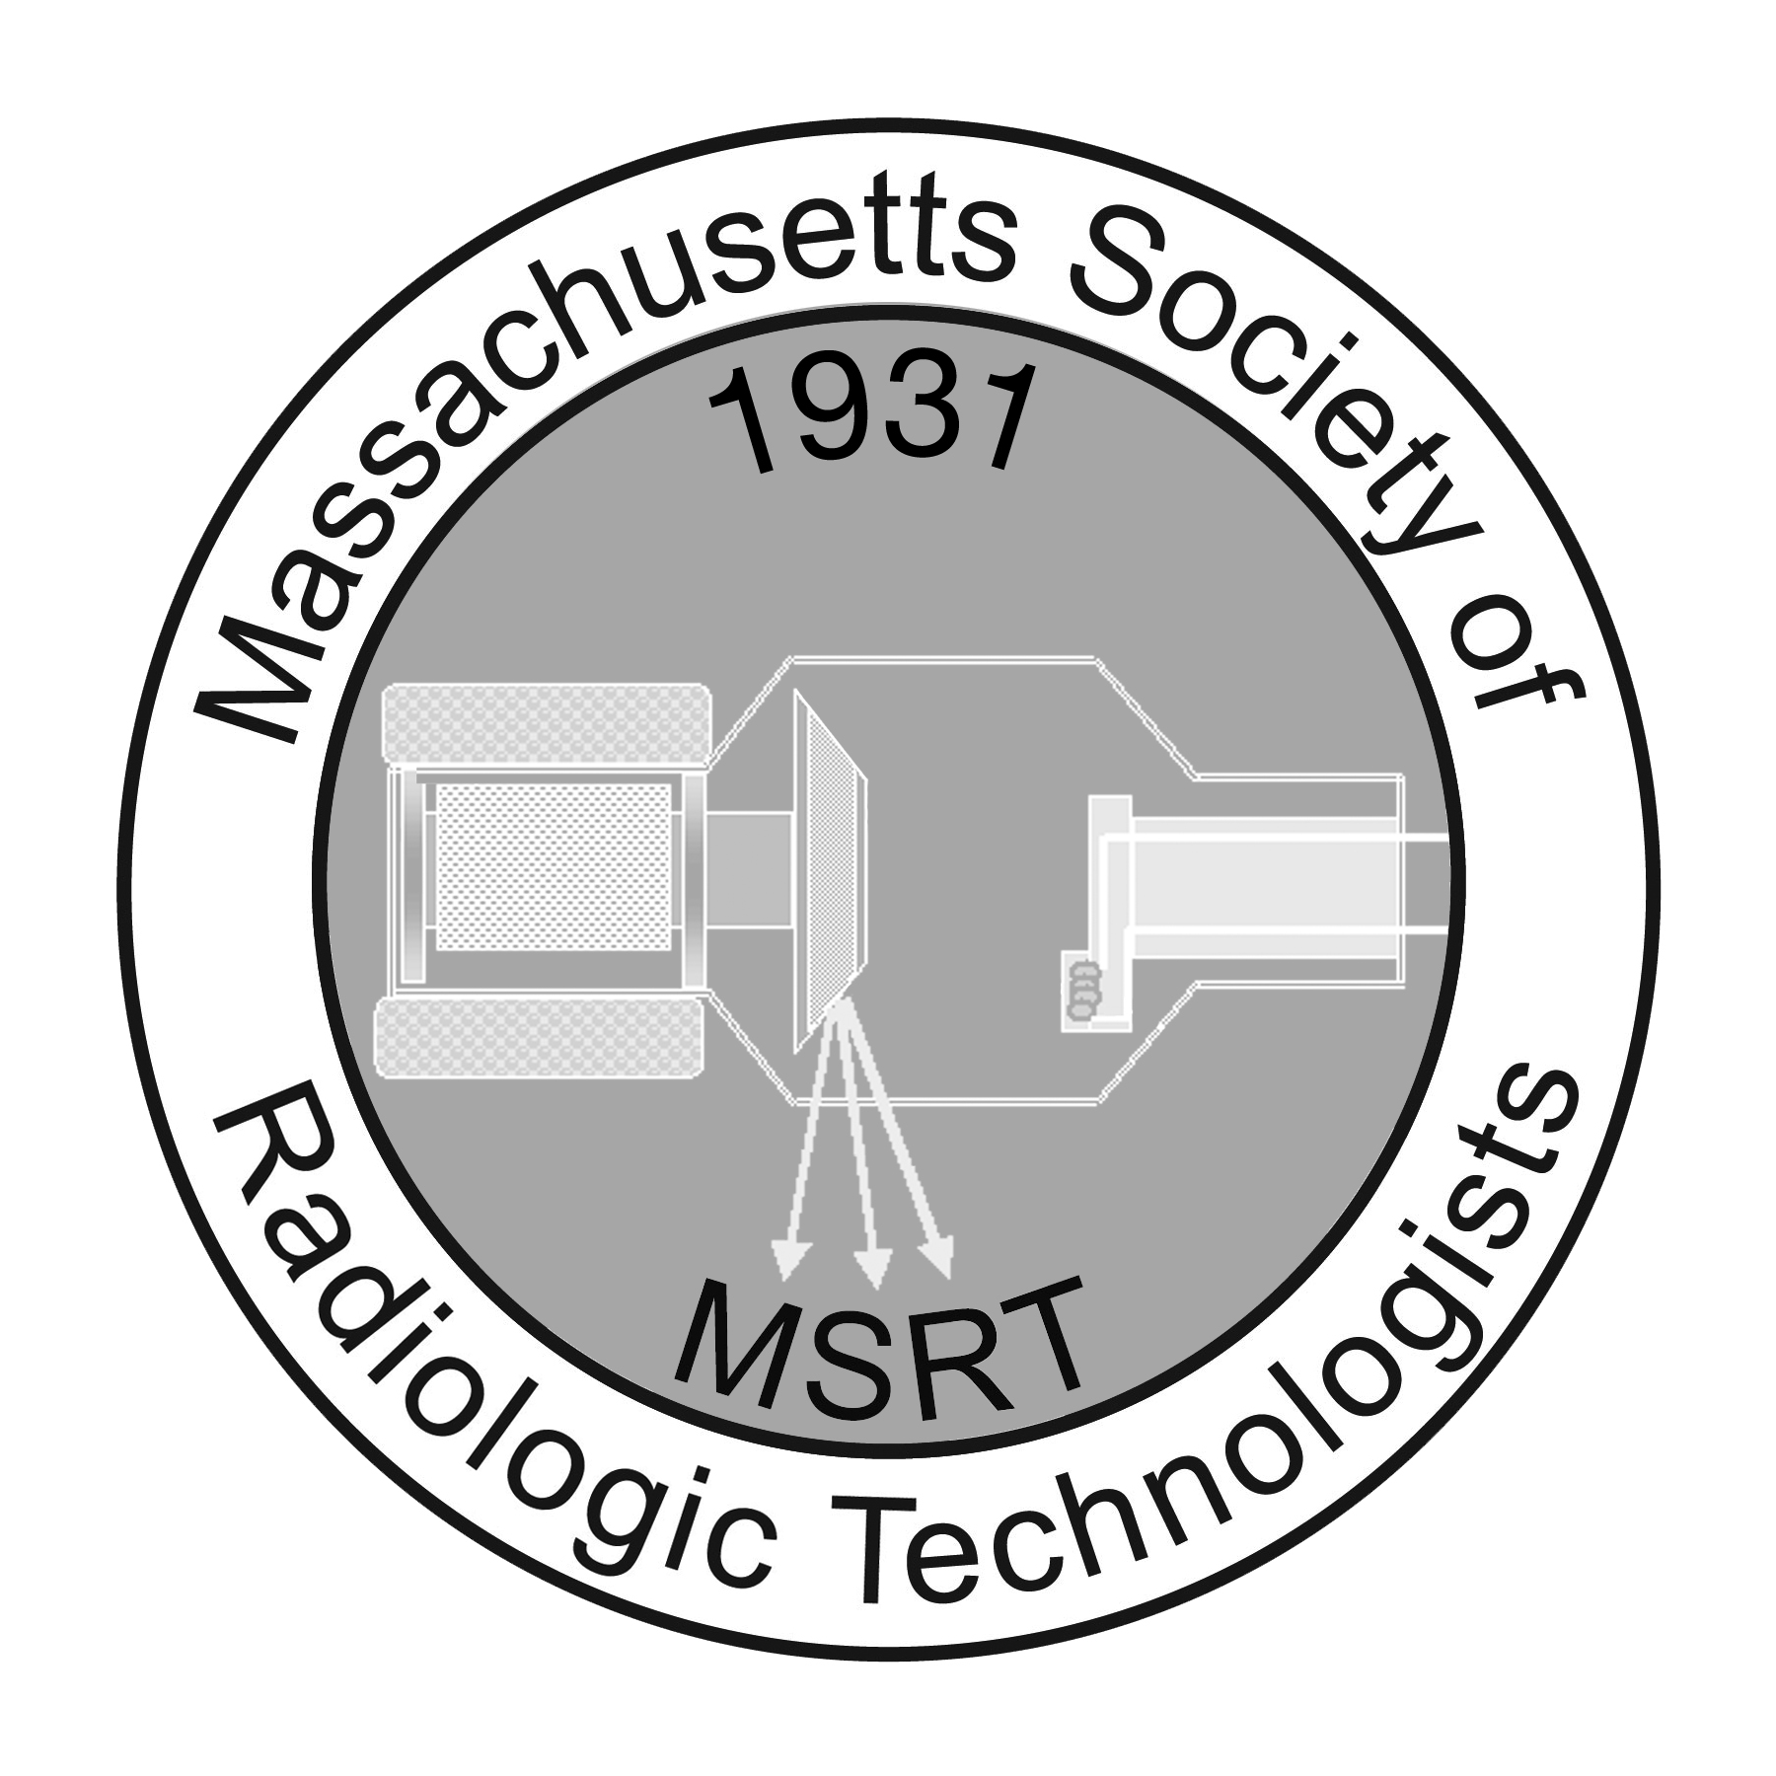

All materials are to be submitted electronically to: info@msrt-ma.org

MSRT Scholarship Application

Dear Educator:

The MSRT is pleased to announce that three entry level scholarships and one professional level scholarship will be awarded at our Annual Conference:

- The Oliver E. Merrill Scholarship sponsored by the MSRT
- Quarter Century Club Scholarships (2)
- An additional scholarship will be awarded this year and is sponsored by the NECC Class of 2017 in memory of their classmate David D. Getty

The purpose of the entry level scholarships is to provide financial assistance to those enrolled in an accredited Radiologic Technology Program. All awards will be considered by the committee based on:

- Academic/professional achievements
- Essay content
- Recommendation

Recipients will be selected by the Scholarship Review Committee & Chairman.

Enclosed please find a copy of the Rules & Regulations along with the application form. It is important that the applicant has full knowledge of these rules & regulations and that the applications are completed properly. Additional applications are available on our website.

Sincerely,
The MSRT Scholarship Committee

MSRT Guidelines for the Florence Wakefield &
Quarter Century Club Scholarships

Entry Level Scholarships:

In order to be considered eligible for MSRT/QCC Scholarships, the following conditions must be met:

- The student must be a member in good standing of the MSRT. Membership must be valid prior to the application deadline.
- The student must have completed at least one semester or quarter, of his or her educational program.
- The student shall have maintained at least 3.0 GPA at the time of application.
- The student shall be enrolled in a Radiologic Technology program within the Commonwealth of Massachusetts accredited by the Joint Review Committee on Education in Radiologic Technology (JRCERT).
- The student shall have applied in the method prescribed by the Executive Board of the MSRT.

Method of Application:
- Complete the Scholarship application.
- In typed essay form, the applicant shall submit a statement of a 250-500 words that discloses:
  - Why are you choosing to make medical imaging your career at this point in your life?
  - Explain the status of your financial need and how this scholarship will affect your current situation.
  - What is it about you that make you the best candidate for this scholarship?
  - Explain your career goals and how your degree or certificate will help you to achieve them.
  - Describe your participation and involvement in the MSRT.
  - Describe your community service and volunteer experience.
  - Describe any academic or clinical awards or recognition you have received.
- Scan and submit an electronic copy of your school transcript showing the most recent semester completed.
- A letter of recommendation from the student’s Clinical Instructor or Clinical Supervisor must be submitted electronically to the MSRT. The recommendation must describe the student’s level of competency and professionalism to include their interactions with patients, staff and peers. Please give the MSRT Scholarship Recommendation Guidelines to the individual writing the recommendations.
- All materials must be submitted electronically to the MSRT no later than February 24, 2017.

Distribution

- Each scholarship shall consist of a cash award. The amount of each scholarship will be determined by the Executive Board of the MSRT.
- The recipients will be requested to attend the business luncheon at the annual MSRT conference to accept their award.
- Applicants are eligible to receive only one scholarship per year.
- The presentation of all scholarships is subject to the availability of funds.

Instructions for the Recommender:

The Massachusetts Society of Radiologic Technologists (MSRT) appreciates your candid appraisal on the merit of the individual applying for a scholarship. The scholarship committee desires an accurate assessment of each applicant. Please comment on the following and email your recommendation to info@msrt-ma.org by February 24, 2017.

- Dates of enrollment in an educational program or employment in your facility.
- Perception of the applicant’s academic, clinical or professional performance to include their interactions with patients, staff and peers.
- Knowledge of applicant’s commitment/intentions to pursue education/accomplish goals.
- Generally, why you recommend the applicant to receive a scholarship.
- Any other information you feel is relevant for the committee’s consideration.
Massachusetts Society of Radiologic Technologists
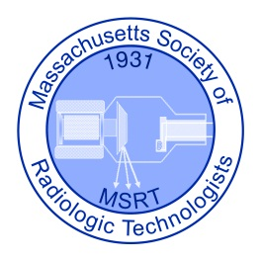
P.O. Box 2821, Duxbury, MA 02331
info@msrt-ma.org www.msrt-ma.org

Entry Level Scholarship Application

Last Name: First Name:
Street Address:
City, State, ZIP:
Telephone: Email:
School: Program of Study:
Enrollment Date: Projected Completion Date:
- In typed essay form, the applicant shall submit a statement consisting of 250-500 words that discloses:
  - Why are you choosing to make medical imaging your career at this point in your life?
  - Explain the status of your financial need and how this scholarship will affect your current situation.
  - What is it about you that makes you the best candidate for this scholarship?
  - Explain your career goals and how your degree or certificate will help you to achieve them.
  - Describe your participation and involvement in the MSRT.
  - Describe your community service and volunteer experience.
  - Describe any academic or clinical awards or recognition you have received.
- Scan and submit an electronic copy of your school transcript showing the most recent semester completed.
- Request letter of recommendation and give guideline to author/s

Please email this application along with your essay and transcript to the MSRT. In addition recommendation letters must be emailed by the author to the MSRT. All documents must be received by February 24, 2017.

Scholarship Application Statement:
The above answers are true and correct to the best of my knowledge. If a discrepancy should arise, I understand my application will be withdrawn from consideration. Your electronic signature binds you to the Scholarship Application Statement.

Photo, Audio, Video Release
By participating in any part of an MSRT Activity, you grant MSRT permission to use your name, likeness and statements about the ACTIVITY in photographs, videos, advertising or any other type of material. Unless you revoke this permission in writing to the MSRT, by virtue of your participation you agree to the use of your likeness in such materials.

Date Submitted: Electronic Signature:

