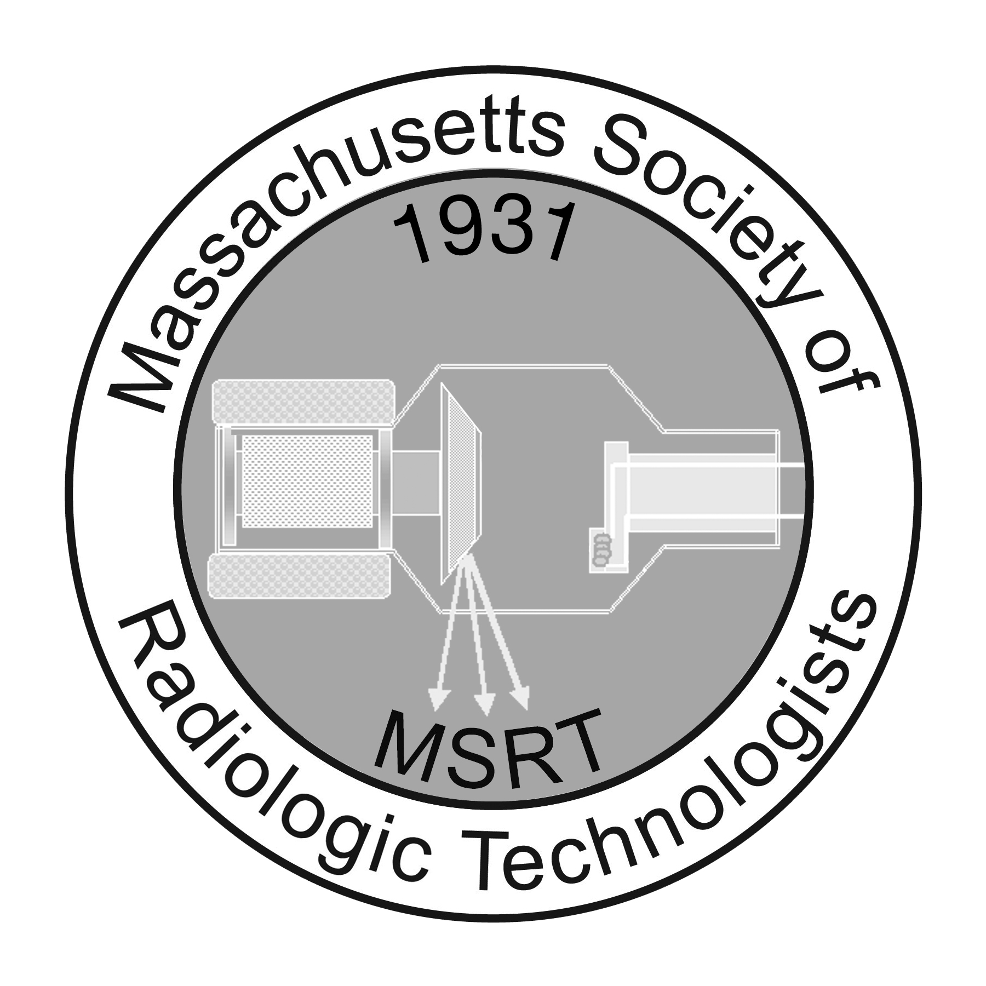

James Lampka Presidential Scholarship

Providing financial assistance to eligible members enrolled in Undergraduate and Graduate Study for Registered Radiologic Technologists

Sponsored by the Quarter Century Club"

In memory of Jim & all he has done for our profession & society

All materials are to be submitted electronically to: info@msrt-ma.org

Introduction

The Massachusetts Society of Radiologic Technologists (MSRT) is committed to advancing the art of radiologic science and to promoting professional advancement among its membership. The MSRT President’s Award assists members seeking an associate, baccalaureate, graduate degree, or additional certifications related to the radiologic sciences. Scholarship amounts are announced each year. The presentation of all scholarships is subject to the availability of funds.

Eligibility Requirements

Professional:

- Current MSRT Membership of at least one (1) year prior to application date
- 2. Current certification and registration with the American Registry of Radiologic Technologists (ARRT)* in a Primary and/or Post Primary category.
(*For those members holding an unrestricted Radiologic Technologist license according to Massachusetts Licensure state statutes, the requirement of registration with the ARRT can be waved.)
- Current Radiologic Technologist license in at least one licensing category from the State of Massachusetts

Academic:

- Cumulative GPA of 3.0 or higher on a 4.0 scale or a completed degree/ professional certificate from an eligible program of study
- Current enrollment in or completion of a program meeting the requirements listed below
  - Graduate Level:
    - Enrolled in a planned course of graduate study­ Master’s or Doctoral degree level (Management/Leadership, Business Administration, Public Health, Education, Radiologic Sciences, etc.)
    - Completed a planned course of study in any of the above mentioned categories within 1 year prior to application
  - Baccalaureate Level:
    - Minimum of sophomore status and enrolled in a baccalaureate degree program related to the radiological sciences
    - Completed a Baccalaureate degree program related to the radiologic sciences within 1 year prior to application
  - Associate’s or Certificate Level:
    - Enrolled in a degree/certificate program related to the radiologic sciences
    - Completed a degree/certificate program related to the radiologic sciences within 1 year prior to application

Restrictions: Previous recipients of the MSRT President’s Award are eligible to reapply once.

Required Supporting Documentation
The following items must be included with application:

- Official transcripts of all completed course work*
(*Unofficial transcripts will be accepted only for current semesters/quarters)
- Two (2) letters of recommendation
  - One (1) professional letter of recommendation (on official letterhead) to include verification of employment in the radiologic sciences for at least one (1) year, within the past five (5) years
  - One (1) academic letter of recommendation (on official letterhead) form school director/faculty/advisor to include verification of completion/enrollment in an eligible program of study
- Resume or curriculum vitae to include relevant extracurricular achievements such as honors, awards, exhibits, etc.
- Documentation (electronic or paper copies) of all “Eligibility Requirements” in the “Professional” category
- Essay* to address:
(*Format: 500 word minimum - 750 word maximum, double-spaced, typed)
  - Career goals
  - Financial need
  - Prior participation and involvement in the MSRT
  - How the scholarship will aid in professional development

Supplemental Information

Instructions for Recommenders:

The Massachusetts Society of Radiologic Technologists (MSRT) appreciates your candid appraisal on the merit of the individual applying for a scholarship. The scholarship committee desires an accurate assessment of each applicant. Please comment on the following and email your recommendation to info@msrt-ma.org by February 28, 2018.

- Dates of enrollment in an educational program or employment in your facility
- Perception of the applicant’s academic, clinical or professional performance to include their interactions with patients, staff and peers
- Knowledge of applicant’s commitment/intentions to pursue education/accomplish goals
- Generally, why you recommend the applicant to receive a scholarship
- Any other information you feel is relevant for the committee’s consideration

Application Deadline:

All applications for the MSRT President’s Award must be submitted on or before February 28, 2018. Incomplete or late applications will not be reviewed.

Selection Process:

- Applications submitted by the stated deadline are reviewed by MSRT staff to verify eligibility (see eligibility criteria)
- Applications meeting the criteria are forwarded to the Scholarship Committee for blind review.
- Each committee member grades the applications according to the point system noted on this page.
- Committee members send graded applications to MSRT staff for compilation.
- The application with the highest scores is chosen as the MSRT President’s Award recipients.

Assessment Criteria:

Application for this Scholarship will be based on a 100% scale broken down as follows:

- Scholastic Standing (10%)
- Clinical Recommendation Evaluation (20%)
- Career Essay (20%)
- Benefit to Professional Development (20%)
- MSRT Involvement (20%)
- Presentation of Application (10%)

Notification Process:

Recipients will be notified by the MSRT. Additionally, names of recipients, program of study, and institutions they attend will be published in MSRT publications and other selected publications as deemed appropriate

Distribution of Funds:

The recipient will be requested to attend the Business Luncheon at the MSRT Annual Conference to accept this award.

All materials are to be submitted electronically to: info@msrt-ma.org

~~~~~~~~~~~~~~~~~~~~~~
James Lampka Presidential
Scholarship Application
~~~~~~~~~~~~~~~~~~~~~~

Name: Click here to enter text.

Address: Click here to enter text.

City: Click here to enter text. State: Click here to enter text. Zip code: Click here to enter text.

Phone: Click here to enter text. Email: Click here to enter text.

Mass Radiology License No.: Click here to enter text. Expiration Date: Click here to enter text.

Are you currently employed in the radiology profession: Yes/No # Hours/Week Click here to enter text.

Are you a previous MSRT President’s Award Scholarship Recipient? Yes/No Year: Click here to enter text.

Radiologic Sciences Education
School | City/State | Diploma/Degree | Completion Date
Click here to enter text. | Click here to enter text. | Click here to enter text. | Click here to enter text.
Click here to enter text. | Click here to enter text. | Click here to enter text. | Click here to enter text.
Click here to enter text. | Click here to enter text. | Click here to enter text. | Click here to enter text.

Institution presently attending: Click here to enter text. Area of concentration: Click here to enter text.

Address: Click here to enter text. Program Director: Click here to enter text.

Program Start Date: Click here to enter text. Projected Completion Date: Click here to enter text.

Please email this application along with your essay, resume and transcripts to the MSRT. In addition, recommendation letters must be emailed by the author to the MSRT. All documents must be received by February 28, 2018.

Scholarship Application Statement:
The above answers are true and correct to the best of my knowledge. If a discrepancy should arise, I understand my application will be withdrawn from consideration. Your electronic signature binds you to the Scholarship Application Statement

Photo, Audio, Video Release
By participating in any part of an MSRT Activity, you grant MSRT permission to use your name, likeness and statements about the ACTIVITY in photographs, videos, advertising or any other type of material. Unless you revoke this permission in writing to the MSRT, by virtue of your participation you agree to the use of your likeness in such materials.

Date Submitted: Click here to enter text. Electronic Signature Click here to enter text.

