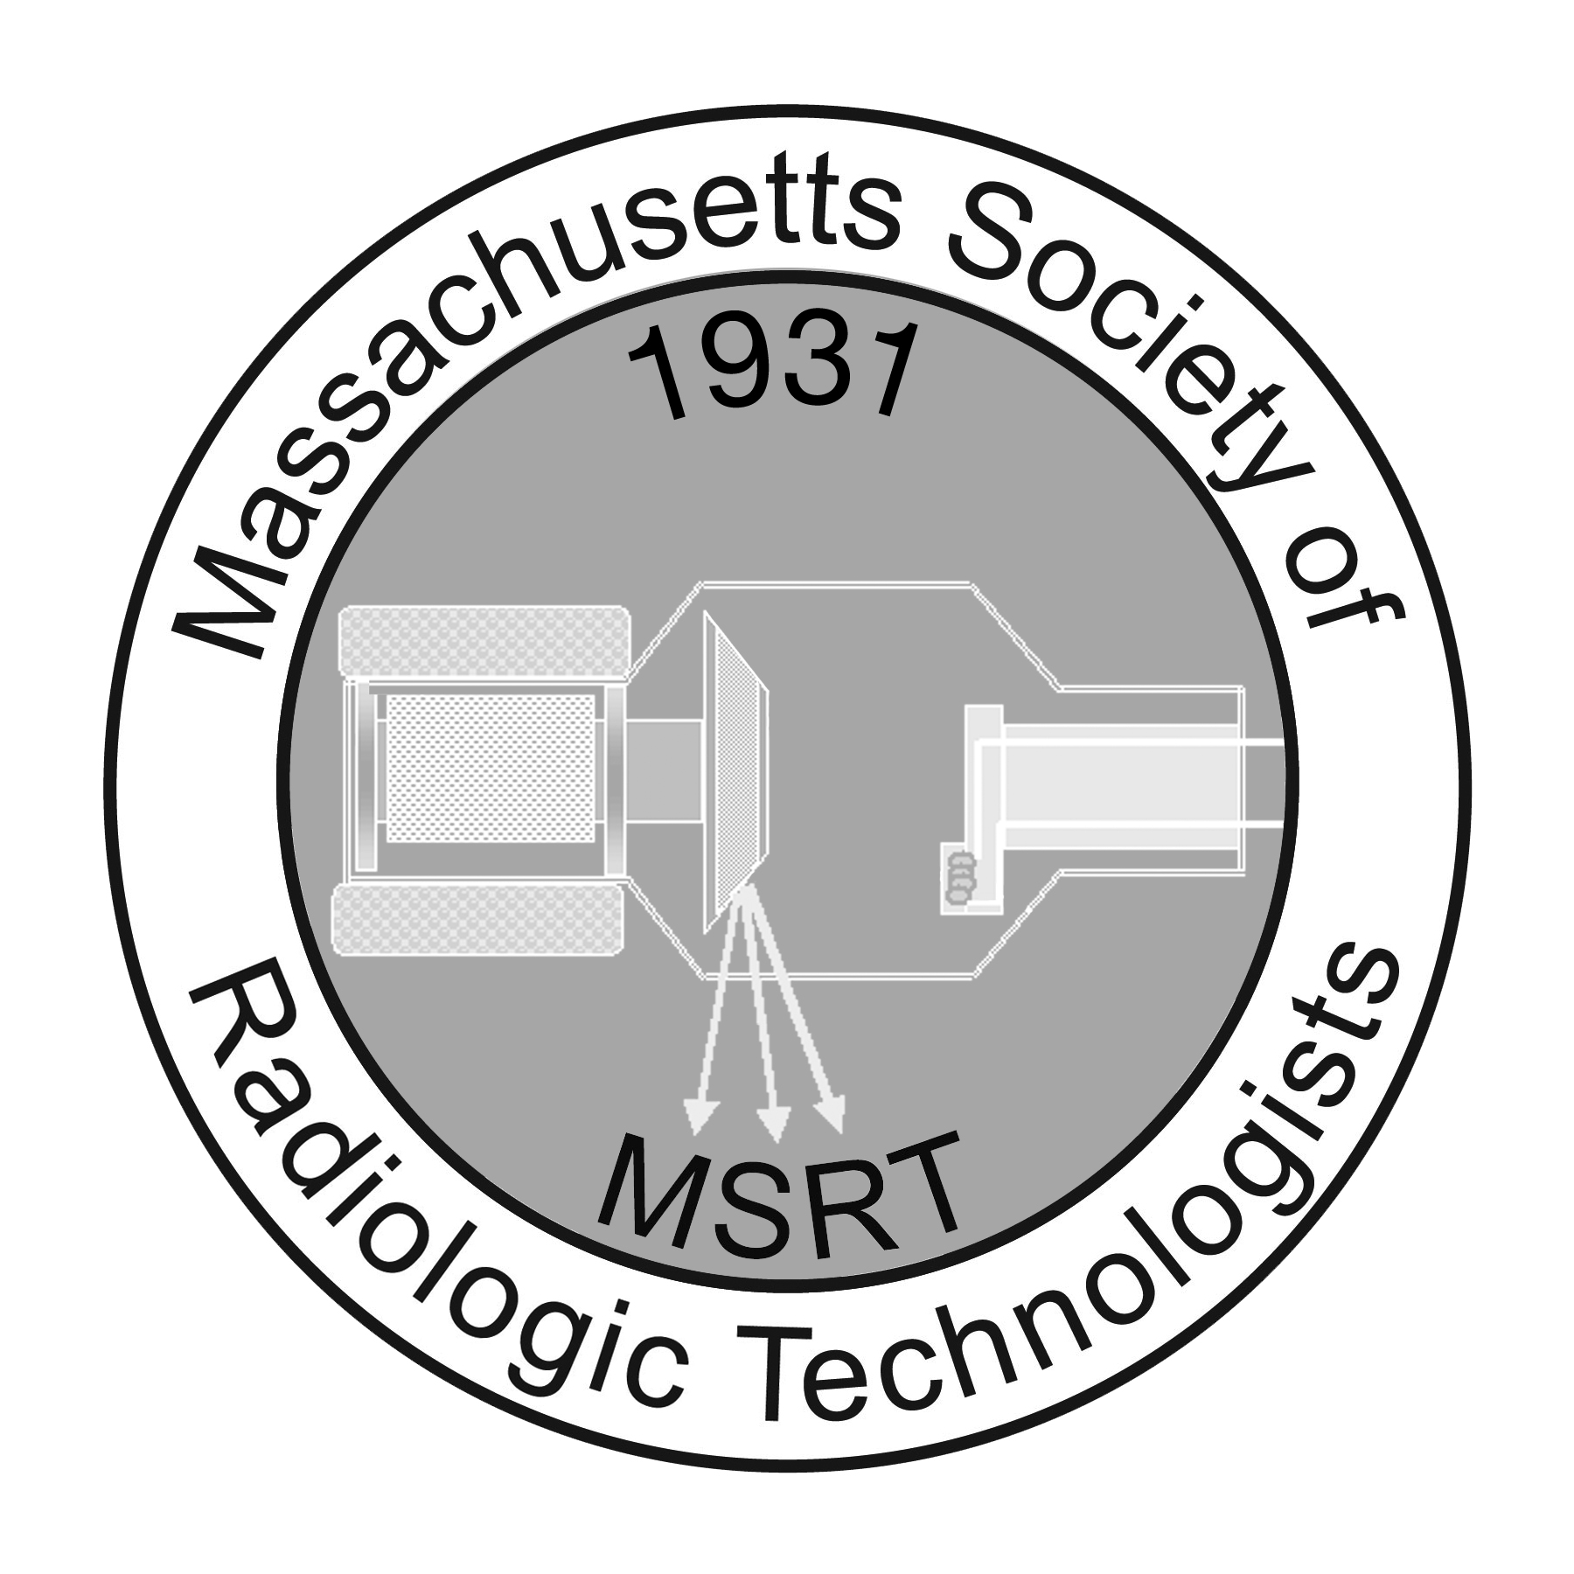

Student Leadership Development Program

The MSRT is among a select group of affiliate societies who were asked to select two students
to represent their state at the 2018 ASRT Student Leadership Development Program.
This application replaces the online ASRT application.

All submissions must submitted electronically to the MSRT Office at info@msrt-ma.org

Program Highlights

The ASRT Student Leadership Development Program offers students a chance to get to know the ASRT, attend educational sessions, and network with medical imaging and radiation therapy professionals.

Selected participants will attend the 2018 ASRT Educational Symposium and Annual Governance and House of Delegates Meeting, June 21-24 in Las Vegas, as well as orientation the evening of June 20.

Selected participants receive:

- Airfare, housing, a stipend for meals and other travel expenses.
- An educational program designed just for students.
- A professional mentor assigned for the meeting.
- An insider's look into the largest association for medical imaging and radiation therapy professionals.
- Expanded opportunities for professional growth.
- Three years of continuing SLDP opportunities.

Eligibility Requirements

Professional:

- Must be a student member of the ASRT and MSRT at time of submission and participation.
- Minimum GPA of 3.0

How To Apply:
- Complete the 2018 SLDP application & submit electronically to the MSRT (info@msrt-ma.org)
- Submit an unofficial college transcript that includes the end of summer 2017 semester
- Submit a 500-750 word essay answering the following two questions:
  - How does active participation in professional organizations enhance the Radiologic Technologist?
  - How would you grow professionally from your participation in the Student Leadership Development Program?
- Submit two recommendation letters;
  - One from your program director, that includes a statement that you have your program director's approval to attend the 2018 ASRT Educational Symposium and Annual Governance and House of Delegates Meeting, June 21-24 in Las Vegas, as well as orientation the evening of June 20th as well as the 2018 MSRT Annual Conference in Leominster, MA April 12-13.
  - One from your primary clinical instructor or preceptor.
- Submit all materials to the MSRT no later than end of business January 19, 2018
- The two students selected will be notified via e-mail Feb. 5th, 2018
If chosen as one of the MSRT student representatives to the ASRT Student Leadership Development Program the recipient will be asked to:
  - Write a brief article for the MSRT newsletter, The Exposure, about their experience as a participant in the Student Leadership Development Program.
  - Attend the MSRT Annual Conference on April 12-13, 2018 and volunteer for 4 hours at either the annual conference or a ½ Day Seminar prior to attending the ASRT Student Leadership Development Program.
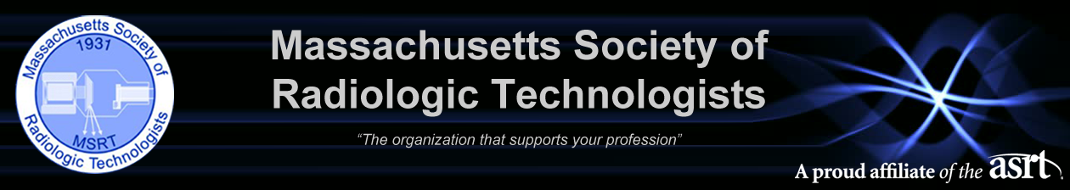2018 MSRT & ASRT Student Leadership Development Program Essay Competition Entry Form

Please e-mail this application along with your essay and transcripts to the MSRT. In addition, recommendation letters and the permission letter of the Program Director should be e-mailed by the author to the MSRT at info@msrt-ma.org. All documents must be received by January 19, 2018.

Name: Click here to enter text.
Address: Click here to enter text.
Home Phone: Click here to enter text. Cell Phone: Click here to enter text.
E-mail address: Click here to enter text.
Will you allow us to share your e-mail address with other participants: ☐Yes ☐No

Name of Radiologic Science Program: Click here to enter text.
Address: Click here to enter text.
Program Director/Administrator: Click here to enter text.
Phone: Click here to enter text. E-mail address: Click here to enter text.
Anticipated Graduation Date: Click here to enter text.
ASRT Member Number: Click here to enter text. MSRT Member Number: Click here to enter text.

Applicant Certification:
☐ I am applying for the Student Leadership Development Program to be held June 22-25, as well as orientation the evening of June 21, during the ASRT Educational Symposium and Annual Governance and House of Delegates Meeting in Orlando, Florida.
☐ I certify that I am a U.S. citizen, U.S. national or U.S. permanent resident. That this application contains no misrepresentations or falsifications and that the information provided is true and correct to the best of my knowledge. I understand that any false statements made herein will void this application, and I will be ineligible. I hereby authorize the release of all information contained in this application packet as may be required to determine my eligibility for selection as a participant. I hereby waive my rights to review any documents pertaining to my application once submitted.
☐ I understand that if I choose to cancel or am unable to attend the Student Leadership Development Program that I will be expected to reimburse the ASRT for all travel costs incurred.
☐ I have read and accept the Student Leadership Development terms and conditions.

Date Submitted: Click here to enter text. Electronic Signature: Click here to enter text.
The following information pertains specifically to the 2018 ASRT Student Leadership Development Program and attendance at the 2018 ASRT Educational Symposium and Annual Governance and House of Delegates Meeting, June 21-24, in Las Vegas.

SLDP Application and Participation Rules

- Application acceptance begins September 15, 2018, at midnight Eastern standard time and ends January 19, 2018, at 11:59 p.m. Mountain time. All entries must be received by the ASRT prior to the end date and time. This contest is only open to participants who submit original essays that they have personally created or those who have been selected by their ASRT affiliate society. Submissions must be in English.
- Each participant may submit only one entry. Up to two applicants per ASRT affiliate shall be selected as winners and notified in February 2018. It is the sole discretion of the ASRT/MSRT to accept or reject any submission. ASRT’s decisions as to the administration, methodology of the 2018 ASRT Student Leadership Development Program and the selection of the winners are final.
- In exchange for acceptance as a participant in the 2018 ASRT Student Leadership Development Program, each recipient agrees to assign to ASRT, upon request, all copyright, trademark and other intellectual property rights in his/her winning essay to ASRT, 15000 Central Ave. SE, Albuquerque, NM 87123.
- Entry participants release ASRT/MSRT and its directors, officers, partners, employees and agents from any and all liability with respect to participation in the 2018 ASRT Student Leadership Development Program and participation in, and travel to or from, the 2018 ASRT Student Leadership Development Program.
- Participation in the 2018 ASRT Student Leadership Development Program may constitute income under applicable federal, state and local tax laws and winners shall be solely responsible for payment of any and all taxes that may be due with respect to the acceptance of the prize.
- Being selected to participate in the 2018 Student Leadership Development Program is nontransferable and may not be redeemed or exchanged for cash or other alternative goods or services. If selected to participate, failure to attend the program may result in the participant being billed for costs incurred by ASRT.
- By submitting an entry, participant agrees that he or she understands and will comply with the official rules and consent to ASRT’s use of the participant’s name, portrait (still and video), picture, voice, likeness and biographical information for advertising, trade and promotional purposes without additional consent, approval, consideration, compensation, permission or notification.
- Original essays submitted with contest entry become the property of the ASRT/MSRT and cannot be returned. The selected essays are not guaranteed to be used by ASRT in any particular way.
- ASRT reserves the right to cancel, modify or suspend the program at its discretion.
- Contest is not open to employees of the ASRT, employees’ immediate relatives, ASRT Editorial Review Board members, ASRT Board members or previous winners.
- The 2018 ASRT Student Leadership Development Program is subject to the laws of the United States of America and is void where prohibited by law.
- The 2018 ASRT Student Leadership Development Program is open only to ASRT student members who are 18 years of age or older and enrolled as a student in an accredited medical imaging or radiation therapy program at the time of submission.
- Selection to participate in the 2018 ASRT Student Leadership Development Program includes complimentary round-trip airfare (must use All World Travel) valued at up to $1,000, a stay at a hotel selected by ASRT, meals provided as part of the program and a daily stipend at the current U.S. General Services Administration’s per diem rates for Las Vegas. Travel arrangements must be made no later than 30 days prior to the event. In the event that a winner lives in the Las Vegas area, or elects not to use the airfare component of the prize, the airfare component will be forfeited, and ASRT/MSRT will provide no compensation or substitution for any difference in prize value.
- By entering, each participant agrees to indemnify, release and hold harmless ASRT/MSRT from and against any and all claims and causes of action of violation of right of publicity, infringement of trademark, copyright or other intellectual property rights, arising from or relating to his or her participation in the 2018 ASRT Student Leadership Development Program.
- The 2018 ASRT Student Leadership Development Program is open only to legal residents of the 50 United States, territories and possessions and the District of Columbia.
Application for the 2018 ASRT Student Leadership Development Program constitutes an agreement of these terms.

