### Massachusetts Society of Radiologic Technologists

**Scientific Paper & Exhibit Submission**

**Guidelines & Application**

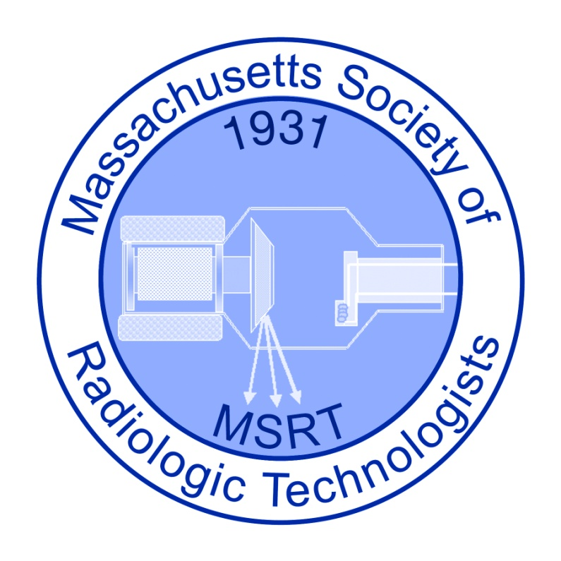

#### All materials are to be submitted electronically to: [info@msrt-ma.org](mailto:info@msrt-ma.org)

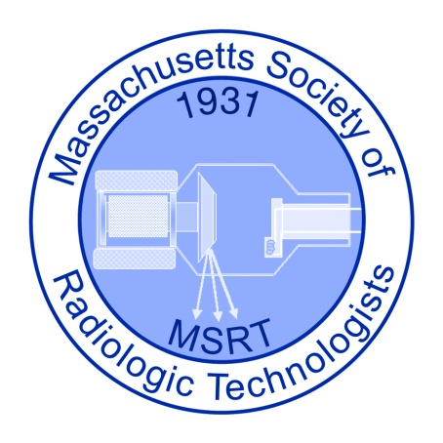

Massachusetts Society of Radiologic Technologists

56 Depot Road, P.O. 2821

Duxbury, MA 02331-2821

2018 MSRT SCIENTIFIC PAPER AND EXHIBIT SUBMISSION RULES

I. ELIGIBILITY

A. All members, technologists and students in good standing with the Massachusetts Society are eligible to compete for awards (exception -- see IB and IC) providing their application and manuscript are emailed to the MSRT office by March 1, 2018.

B. The following members may not participate in the competition: President, Annual Conference Chairperson and Co-Chairperson, and Exhibit Judges, or persons employed by commercial firms engaged in the sale or manufacture of x-ray products.

C. Papers previously submitted for competition at any radiological meeting (ASRT, RSNA, etc.) may not be submitted for competition.

II. JUDGING

The three judges shall be selected by the MSRT Board and will be responsible only to the Conference Chairperson and the President of the Society. Scientific papers and exhibits must meet the established criteria. The judges’ selections shall be decided by the ratings listed in the *Scientific Paper and Scientific Exhibit Evaluation* *Scales Criteria* based upon the established rubric for each criterion. A copy of the evaluation rubric for the paper and exhibit will be made available to all submitting a scientific paper or scientific exhibit.

III. AWARDS

Prizes will be awarded according to the point score obtained under the criteria for the Scientific Paper and Scientific Exhibit. All prizes need not be awarded. The decision of the judges is final.

IV. ADDRESS

Only those scientific /exhibit papers, which have been emailed to the address on the application form, will be accepted. Only the two-page paper needs to be submitted at this time if you are presenting an exhibit.

SCIENTIFIC PAPERS

1. All papers must be original with the author who submits them.
2. Papers must be consist of subject matter pertaining to radiologic technology (examples but not conclusive; a presentation of a pathology, screen-film versus digital image quality, creativity in positioning) or a project that will enhance the radiology knowledge of the general population or providing important information regarding the role of radiology in healthcare.
3. The papers must be prepared letter sized paper, double spaced, 1.5 inch margins, one-sided using a size 10 font.
4. Papers should be no less than 8 pages (including cover).
5. The text of the paper shall contain no means of identification such as pictures, references to physicians, hospitals, schools, or other clues to the author’s identity. The title page of the original shall bear the author’s name and address or workplace in addition to the title of the work. The title page of the copies shall contain no identification other than the title.
6. All papers must include a bibliography/works cited page.
7. Please use the APA guidelines for a research paper and accurate source citing.
8. All applicants must complete the *Release Form for Scientific Paper/Exhibit Submission.*

SCIENTIFIC PAPER EVALUATION SCALE CRITERIA

1. Originality: 40 points
2. Evidence of original effort or ingenuity.
3. Resources must not be published prior to 2008 to ensure the information is current and relevant to current imaging practices.
4. Thirty Percent (30%) of the research material must not be taken from a website.

1. Organization of Material: 20 points

Development: Is material orderly and presented in logical sequence?

1. Mechanics: 40 points

Proper grammar, spelling, punctuation, and neatness will be evaluated as will proper sighting of resources using the APA format.

Papers must score a minimum of 60 points for third place award, 70 points for second place, and 80 points for first place.

SCIENTIFIC EXHIBITS

1. All exhibits must be the work of the individual technologists or student.
2. Exhibits may must consist of subject matter pertaining to radiologic technology (examples but not conclusive a presentation of a pathology, screen-film versus digital image quality, creativity in positioning), or a project that will enhance the knowledge of the general population or provides important information regarding the role of radiology in healthcare (examples but not conclusive, an informative video, a community outreach project, a brochure, a presentation to a specific group).
3. A minimum two page paper must be included with the exhibit describing the purpose of the project. The papers must be prepared letter sized paper, double spaced, 1.5 inch margins, one-sided using a size 10 font. The paper must includea bibliography/works cited page, using the APA guidelines for a research paper and accurate source citing.
4. The exhibitor’s name and work place may appear on the exhibit, but must remain covered until completion of judging. No means of identification such as pictures, references to physicians, hospitals, or schools shall be permitted. The title page of the original shall bear the author’s name and address or workplace in addition to the title of the work.
5. All markings on images must be removed so that identification of the patient is not possible.
6. It is the responsibility of the individual submitting a scientific exhibit to inquire if the images can be copied for the purpose of using in their presentation.
7. The total space allotted for any one exhibit shall not exceed five linear feet of table or wall space. Eight 14"x17 " illuminators and may be used in four- over -four configuration Illuminators and extension cords must be provided by the exhibitor.
8. The exhibitor is responsible for his/her exhibit. The MSRT is not responsible for loss or damage. The MSRT, however, will take all reasonable precautions to ensure the safety of exhibits during display.
9. Exhibits should be in place by 8:00 AM on Day 1 of the conference & must be removed by 2:30 PM on the last day of the conference.
10. All applicants must complete the *Release Form for Scientific Paper/Exhibit Submission.*

SCIENTIFIC EXHIBIT EVALUATION CRITERIA

1. ORIGINALITY: 25 POINTS

1. Highly unique original topic.
2. Creative exhibit construction and/or use of materials.
3. Proper referencing and credit given to all previously published material used in exhibit.
4. Accuracy of materials presented.

B. ORGANIZATION: 20 POINTS

1. The degree to which the materials presented relates to the major topic of the exhibit.
2. The degree to which the materials presented follows a logical sequence and maintains an evident continuity.

C. MECHANICS: 25 POINTS

1. Proper grammar, spelling, punctuation, and neatness will be evaluated on all typed material presented.
2. Visual Material: Are drawings or illustrations used to support or promote understanding of the text?

D. OVERALL MERIT: 30 POINTS

1. The depth and/or scope of theoretical/practical knowledge and expertise incorporated into the materials presented.
2. The degree to which the materials presented is of direct value to the upgrading of the
3. performance /attitudes/technical standards in the profession or enhances the radiology knowledge of
4. the general population or provides important information regarding the role of radiology in healthcare.

Exhibits must score a minimum of 60 points for third place award,

70 points for second place and 80 points for first place.

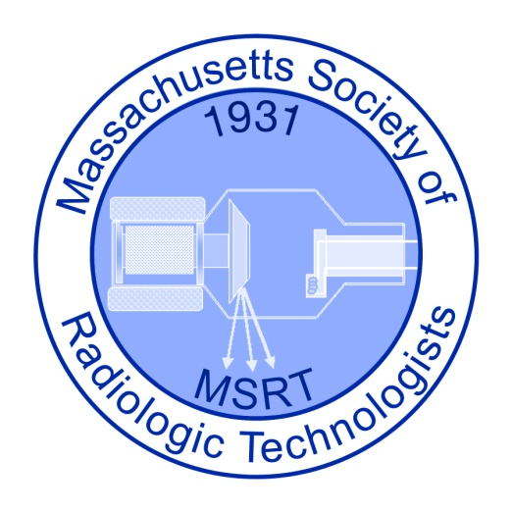

2018 MSRT Annual Conference

Scientific Exhibits & Professional Paper Contest

# APPLICATION FORM

Name: 

Address: 

City:  State:  Zip: 

Email Address: 

Daytime Phone: 

School: 

Projected Date of Graduation: 

The Title of my Paper/Exhibit is: 

## Please complete & email this application form to the MSRT office [info@msrt-ma.org](mailto:info@msrt-ma.org) by March 1, 2018

# **Release Form for Scientific Paper Submissions**

C:\Users\MSRT\AppData\Local\Microsoft\Windows\Temporary Internet Files\Content.IE5\20VRXHME\MCBS01872_0000[1].wmf

I, the undersigned, do hereby consent and agree that The Massachusetts Society of Radiologic Technologists (MSRT), its employees, or agents have the right to publish my 2018 Scientific Paper Submission. I do hereby release to The Massachusetts Society of Radiologic Technologists (MSRT), its agents, and employees all rights to exhibit this work in print and electronic form on the society’s website.

I represent that I am at least 18 years of age, have read and understand the foregoing statement, and am competent to execute this agreement.

Name: 

Address: 

Phone: 

Signature: 

*By electronically signing this document & submitting the the MSRT Office via email, I hereby bind myself to the statements above.*