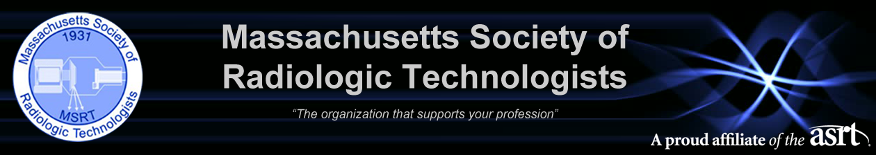2024 MSRT & ASRT Student Leadership Development Program
Essay Competition Entry Form

Please e-mail this application along with your essay and transcripts to the MSRT. In addition, recommendation letters and the permission letter of the Program Director should be e-mailed by the author to the MSRT at info@msrt-ma.org. All documents must be received by November 10, 2023 at 11:59 pm EST.

Name: Click here to enter text.
Address: Click here to enter text.
Home Phone: Click here to enter text. Cell Phone: Click here to enter text.
E-mail address: Click here to enter text.
Will you allow us to share your e-mail address with other participants: ☐Yes ☐No
Name of Radiologic Science Program: Click here to enter text.
Address: Click here to enter text.
Program Director/Administrator: Click here to enter text.
Phone: Click here to enter text. E-mail address: Click here to enter text.
Anticipated Graduation Date: Click here to enter text.
ASRT Member Number: Click here to enter text. MSRT Member Number: Click here to enter text.
Applicant Certification:
☐ I am applying for the Student Leadership Development Program to be held June 27-30, 2024 • Rosen Centre Hotel, Orlando, FL, as well as orientation the evening of June 26, during the ASRT Educational Symposium and Annual Governance and House of Delegates Meeting.
☐ This application contains no misrepresentations or falsifications and that the information provided is true and correct to the best of my knowledge. I understand that any false statements made herein will void this application, and I will be ineligible. I hereby authorize the release of all information contained in this application packet as may be required to determine my eligibility for selection as a participant. I hereby waive my rights to review any documents pertaining to my application once submitted.
☐ I understand that if I choose to cancel or am unable to attend the Student Leadership Development Program that I will be expected to reimburse the ASRT for all travel costs incurred.
☐ I have read and accept the Student Leadership Development terms and conditions.

Date Submitted: Click here to enter text. Electronic Signature: Click here to enter text.

